Suggestion on website

(as discussed in meeting on 9.7.2020)

* 1. Tabs should show active movement after touch of cursor. Where ever possible, add picture or icon along with name for presentation.
  2. College name correction. Training Ship Rahaman instead of Training Ship Rahaman College. Spelling check.
  3. Font for Training Ship Rahaman as per old web site.

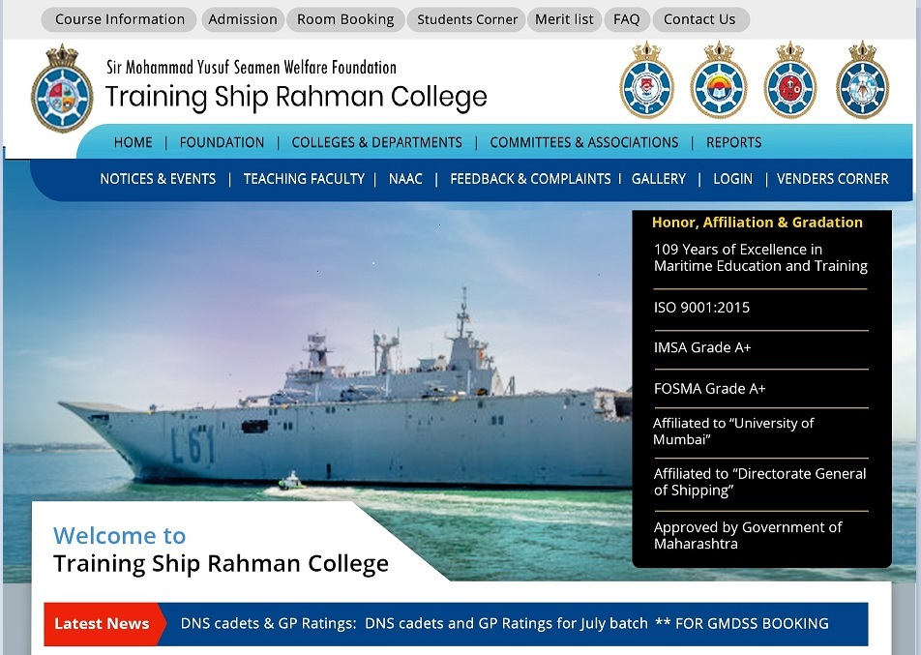

* 1. Change photo, need merchant ship photo and not Indian navy.

Image 6.

oakland-ca-march-14-2017-260nw-601658942 1

EMMA_MAERSK 1

(<https://www.google.com/search?q=free%20download%20images%20of%20merchant%20ships&tbm=isch&hl=en-GB&hl=en-GB&tbs=rimg%3ACb4uWiGKiIsWYRbnQSINm6sZ&ved=0CBsQuIIBahcKEwjgyYKklMDqAhUAAAAAHQAAAAAQFQ&biw=1263&bih=519>)

* 1. Remove “Welcome to Training Ship Rahaman” strip which is on photos.
  2. Add icon of - Facebook, Twitter, Email, Admission 2020 (Link it to Online Course Booking tab.)
  3. Honour Board Cnanges – 109 >110. IMSA & FOSMA remove. Use approved word instead of Affiliated in DG shipping.

First line – Notices and Events, Students corner, Gallery, Venders corner, Merit list, FAQ, Login, Contact Us

* 1. Notices and Events,

Notices and Events- New Tab. Three sub tabs on one page.

1. Notices
2. News
3. Events
   1. Students Corner,

Students Corner –

1. Students login - New sub tab.
2. Alumni - New sub tab.
3. Document verification. - New sub tab.
   1. Gallery -
4. Photo Gallery
5. Video Gallery
6. Students Testimonial
   1. Venders corner
7. Venders Registration Form
8. Venders Evaluation Forms
   1. Merit list – Page with information.
   2. FAQ -
9. Courses available in TSR.
10. Booking of course or admission in TSR.
11. Booking of Hostel in TSR.
12. Visit to TSR.
13. Procedure for Cancellation of course booking and fees refund. (**Cancellation and Fees Refund Policy.)**
14. Privacy Policy and Terms of Service of TSR. (**Privacy Policy and Terms of Service)**
15. Special instructions of all courses.
    1. Login
16. Faculty Login. Appex link.
17. Student Login. – only tab.
    1. Contact Us – Web site content.

Second line – Home, Foundation, Course Information, Post Sea Course Booking, Pre-Sea Course Booking /Admission”, Room Booking

* 1. Home
  2. Foundation – all current tabs on your demo page.
  3. Course Information – Programmes / Courses - It is list of all course name with hyperlink to details. Remove all sub tabs. Add info page.
  4. Post Sea Course Booking - Add ‘Post sea online” link to it of old website. It is Appex software.
  5. Pre-Sea Course Booking /Admission – it is one tab. **Pre Sea and University Admission.** Add ‘Admission 2020” link to it of old website. It is Appex software.
  6. Room Booking – Page with information.

Third line - Colleges & Departments, Teaching Faculties, NAAC, Committees and Associations, Feedback and Complaints, Reports

* 1. The Colleges & Departments

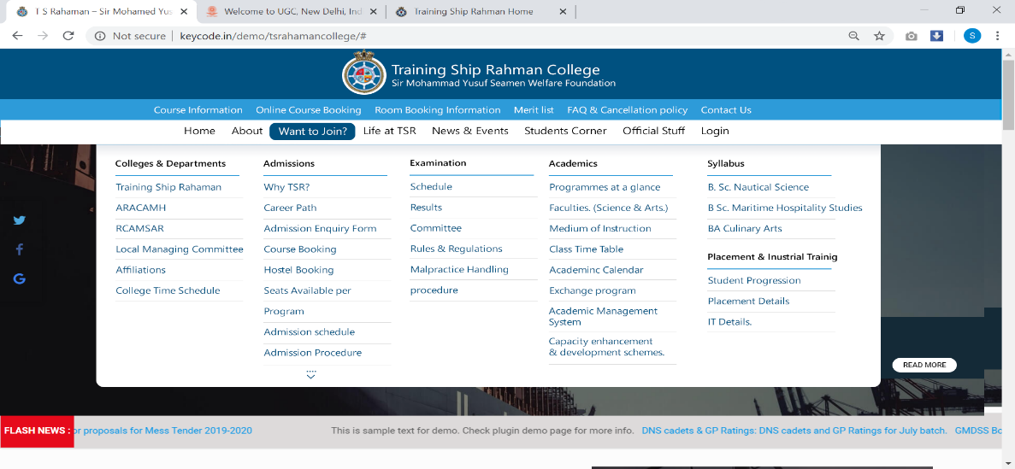

1. The Colleges & Departments
2. TSR – old website page - <http://www.tsrahaman.org/tsr.html>
3. ARACAMH – old website page - <http://www.tsrahaman.org/aracah.html>
4. RCAMSAR – old website page - <http://www.tsrahaman.org/rcamsar.html>
5. College Infrastructure and Facilities
6. Committees and Associations – Add new tab.
7. Sports and Cultural events. - Add new sub tab.
8. Reports. – Add new tab.
9. Human Resource - Add new sub tab.
10. Application form for faculty – Rename as ‘Job Application’
11. Job vacancy list - Add info page.
12. Organisational Structure – Rename as “Governance and Administration”. Add info page.
13. Teaching Staff – Add info page.
14. Non-Teaching Staff – Add info page.
15. HRM Policy. - Add info page.
16. Leave Rules - Add info page.
17. Code of conduct - Add info page.
18. Act and Policies - Add info page.
19. Admission
20. Why TSR?
21. Career Path – Add info page. with course list – give old website link of career path of each course.
22. Admission Enquiry Form – Add info page.
23. Course Booking – Link to Online course booking tab.
24. Hostel Booking – Add info page.
25. Seats Available Per Program – change to “Programs -Total Seats and Faculty”. Add info page.
26. Admission schedule - Add info page. . - Add ‘Admission 2020” link to it of old website. It is Appex software.
27. Admission Procedure - Add info page.
28. Fees Structures - Add info page.
29. Merit Lists - Link to Merit Lists tab.
30. Admission cancellation policy - Add info page.
31. Parent / Guardian Consent Form – Use link given in old website.
32. Undertaking by Parents / Legal Guardians - Use link given in old website.

1. Academic
2. Programmes at a glance - Add info page.
3. Medium of Instruction - Add info page.
4. Class Time table - Change to “College Time Schedule”
5. Research – Add new tab in academic and remove from main page.
6. Govt. & TSR Leave Calendar - Add new tab. Add info page.
7. Faculty Exchange Program - Add new tab.
8. Syllabus - Add new tab.
9. ICT - Add new tab.
10. PO’S CO’S and PSO’S - Add new tab.
11. Examination - Add info page.
12. Examination Committee
13. Examination rules and regulations
14. Examination Schedules.
15. Examination results.
16. Exam Reports
17. Library.
18. Library
19. Total Collection
20. Library Timing.
21. Library services and facilities
22. Infrastructure and Learning Resources
23. Library Committee and Staff Details
24. Campus Roundabout
25. George Campbell Library Current Awareness Service
26. Competitive Examinations Centre
27. Important Links
28. Placement and IT - Add info page.
    1. Teaching Faculties,

Teaching Faculties - Use old website data – ‘Faculty’.

* 1. NAAC

1. Internal Quality Assurance Committee
2. Academic Audit Report
3. Meeting Details
4. Important Document Link
   1. Committees and Associations
   2. Feedback and Complaints –
5. Feedback on students
6. Feedback on
7. Feedback on
8. Feedback on
   1. Reports – List of reports.
   2. Flash News (Read all/Detail) –



Read all/Details

* 1. Our Courses –

Eight photos tabs – 4 in one line.

B. Sc. Nautical Science, B. Sc. Maritime Hospitality Studies, BA Culinary Arts, Diploma in Nautical Science (IMU-DNS)

Pre-Sea General Purpose Rating (GP Rating), Certificate Course in Maritime Catering (CCMC), STCW, Graduate Mechanical Engineers (GME)

View All Courses.

* 1. Administrative Services and Facilities –

Add all facilities which are important for NAAC.

* 1. News and events reduce to 3 points.
  2. News letter and For an enquiry which is on old website at last is missing in new template.